UNIVERSAL OSTRICH FARM (301) AND SURROUNDING PROPERTY
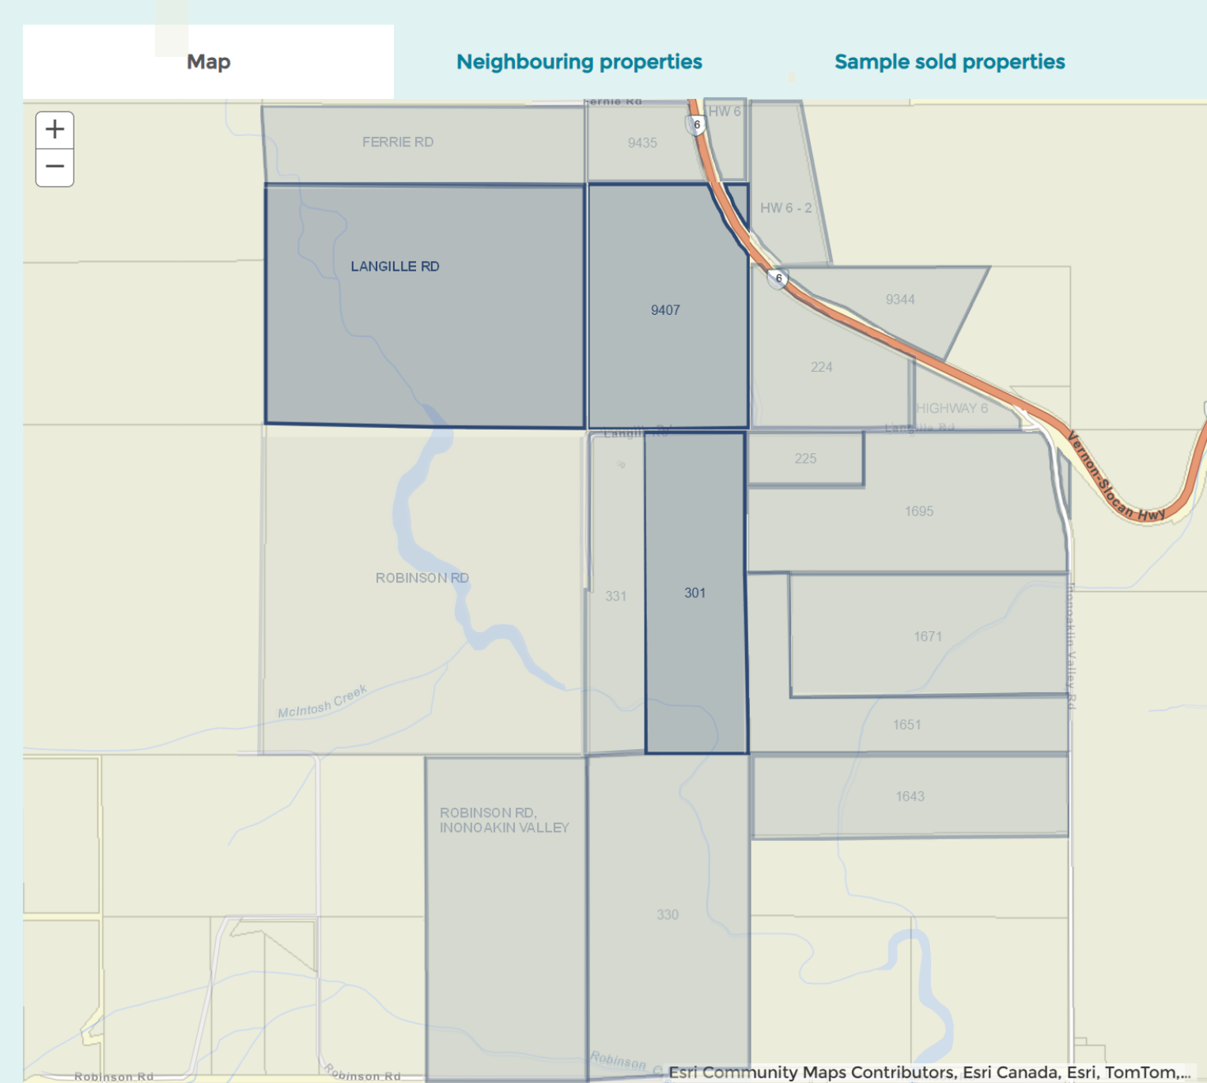
BC Assessment - Independent, uniform and efficient property assessment |  | https://www.bcassessment.ca/
Address | Link | Land | Buildings | Total | Acres | NOTES
301 LANGILLE RD INONOAKLIN VALLEY | https://www.bcassessment.ca/Property/Info/QTAwMDBSMU1FWQ== | $ 430,000 | $ 390,000 | $ 820,000 | 50 Acres | FARM
9407 HIGHWAY 6 INONOAKLIN VALLEY | https://www.bcassessment.ca/Property/Info/QTAwMDBSMU1GTQ== | $ 27,186 | $ 45,800 | $ 72,986 | 58.38 Acres | OSTRICHES
LANGILLE RD INONOAKLIN VALLEY | https://www.bcassessment.ca/Property/Info/QTAwMDBSMU1GVQ== | $ 567,000 | $ - | $ 567,000 | 120 Acres | BURIALS?
331 LANGILLE RD INONOAKLIN VALLEY | https://www.bcassessment.ca/Property/Info/QTAwMDBSMU1FWA== | $ 328,000 | $ 184,000 | $ 512,000 | 28.78 Acres | UNKNOWN
ROBINSON RD | https://www.bcassessment.ca/Property/Info/QTAwMDBSMU1FVw== | $ 620,000 | $ 125,000 | $ 745,000 | 160 Acres | UNKNOWN
224 LANGILLE RD EDGEWOOD V0G 1J0 | https://www.bcassessment.ca/Property/Info/QTAwMDBSMU1GTA== | $ 328,000 | . | $ 328,000 | 28.55 Acres | UNKNOWN
225 LANGILLE RD INONOAKLIN VALLEY | https://www.bcassessment.ca//Property/Info/QTAwMDBSMU1GRA== | $ 5,718 | $ 90,918 | $ 97,918 | 9.28 Acres | UNKNOWN
1695 INONOAKLIN VALLEY RD INONOAKLIN VALLEY | https://www.bcassessment.ca//Property/Info/QTAwMDBSMU1GQw== | $ 38,354 | $ 118,500 | $ 156,854 | 56.54 Acres | UNKNOWN
1671 INONOAKLIN VALLEY RD INONOAKLIN VALLEY | https://www.bcassessment.ca//Property/Info/QTAwMDBSMU1GMQ== | $ 33,731 | $ 74,600 | $ 108,331 | 49.25 Acres | UNKNOWN
1651 INONOAKLIN VALLEY RD INONOAKLIN VALLEY | https://www.bcassessment.ca//Property/Info/QTAwMDBSMU1GNg== | $ 26,758 | $ 181,000 | $ 207,758 | 39.63 Acres | UNKNOWN
330 ROBINSON RD INONOAKLIN VALLEY | https://www.bcassessment.ca/property/info/print/QTAwMDBSMU1FTQ== | $ 467,000 | $ 42,400 | $ 509,400 | 78.44 Acres | UNKNOWN
ROBINSON RD INONOAKLIN VALLEY | https://www.bcassessment.ca/Property/Info/QTAwMDBSMU1FTA== | $ 469,000 | $ - | $ 469,000 | 80 Acres | UNKNOWN
604 ROBINSON RD INONOAKLIN VALLEY | https://www.bcassessment.ca/Property/Info/QTAwMDBSMU1FOQ== | $ 67,789 | $ 193,000 | $ 260,789 | 78.84 Acres | UNKNOWN
9435 HIGHWAY 6 INONOAKLIN VALLEY | https://www.bcassessment.ca/Property/Info/QTAwMDBSMU1GUw== | $ 270,000 | $ 96,200 | $ 366,200 | 13.36 Acres | UNKNOWN
FERRIE RD INONOAKLIN VALLEY | https://www.bcassessment.ca/Property/Info/QTAwMDBSMU1GVg== | $ 209,000 | $ 7,400 | $ 216,400 | 40 Acres | UNKNOWN
HIGHWAY 6 INONOAKLIN VALLEY (HW 6) | https://www.bcassessment.ca/Property/Info/QTAwMDBSMU1GUg== | $ 131,300 | $ - | $ 131,300 | 4.34 Acres | UNKNOWN
HIGHWAY 6 INONOAKLIN VALLEY (HW 6 - 2) | https://www.bcassessment.ca/Property/Info/RDAwMDE0SFRQUg== | $ 196,300 | $ 111,000 | $ 307,300 | 15.568 Acres | UNKNOWN
9344 HIGHWAY 6 INONOAKLIN VALLEY | https://www.bcassessment.ca/Property/Info/QTAwMDBSMU1GTg== | $ 240,300 | $ 350,000 | $ 590,300 | 16.14 Acres | UNKNOWN

BC Assessment - Independent, uniform and efficient property assessment |  | https://www.bcassessment.ca/
Address | Link | Land | Buildings | Total | Acres | NOTES
301 LANGILLE RD INONOAKLIN VALLEY | https://www.bcassessment.ca/Property/Info/QTAwMDBSMU1FWQ== | $ 430,000 | $ 390,000 | $ 820,000 | 50 Acres | FARM
9407 HIGHWAY 6 INONOAKLIN VALLEY | https://www.bcassessment.ca/Property/Info/QTAwMDBSMU1GTQ== | $ 27,186 | $ 45,800 | $ 72,986 | 58.38 Acres | OSTRICHES
LANGILLE RD INONOAKLIN VALLEY | https://www.bcassessment.ca/Property/Info/QTAwMDBSMU1GVQ== | $ 567,000 | $ - | $ 567,000 | 120 Acres | BURIALS?
331 LANGILLE RD INONOAKLIN VALLEY | https://www.bcassessment.ca/Property/Info/QTAwMDBSMU1FWA== | $ 328,000 | $ 184,000 | $ 512,000 | 28.78 Acres | UNKNOWN
ROBINSON RD | https://www.bcassessment.ca/Property/Info/QTAwMDBSMU1FVw== | $ 620,000 | $ 125,000 | $ 745,000 | 160 Acres | UNKNOWN
224 LANGILLE RD EDGEWOOD V0G 1J0 | https://www.bcassessment.ca/Property/Info/QTAwMDBSMU1GTA== | $ 328,000 | . | $ 328,000 | 28.55 Acres | UNKNOWN
225 LANGILLE RD INONOAKLIN VALLEY | https://www.bcassessment.ca//Property/Info/QTAwMDBSMU1GRA== | $ 5,718 | $ 90,918 | $ 97,918 | 9.28 Acres | UNKNOWN
1695 INONOAKLIN VALLEY RD INONOAKLIN VALLEY | https://www.bcassessment.ca//Property/Info/QTAwMDBSMU1GQw== | $ 38,354 | $ 118,500 | $ 156,854 | 56.54 Acres | UNKNOWN
1671 INONOAKLIN VALLEY RD INONOAKLIN VALLEY | https://www.bcassessment.ca//Property/Info/QTAwMDBSMU1GMQ== | $ 33,731 | $ 74,600 | $ 108,331 | 49.25 Acres | UNKNOWN
1651 INONOAKLIN VALLEY RD INONOAKLIN VALLEY | https://www.bcassessment.ca//Property/Info/QTAwMDBSMU1GNg== | $ 26,758 | $ 181,000 | $ 207,758 | 39.63 Acres | UNKNOWN

